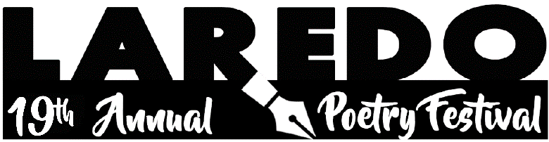

Date: Saturday, April 23, 2022
Time: 1:00 – 2:00 p.m.
Location: Multipurpose Room, Laredo Public Library (1120 E Calton road)
Subject:
- “Every day is new beginning” is the central theme for 19th Annual Poetry Festival.
- Or the theme can be any topic you may want to write about.

Rules of Participation:
- Poems must be original; plagiarized poems will be disqualified.
- Poems may be written in any format.
- Poems should be no longer than 2 pages, double-spaced.
- Submit 2 copies of your poem, 1 with no name on it.
- Only one entry per individual person will be accepted; no co-authors of a poem will be accepted.
- No poem will be accepted through fax.
- The application form needs to be filled out.
- The parents or legal guardian will fill out the Release Form for students under 18.

Language:
- English or Spanish.

Participants:
- Students from LISD, UISD, private schools, and home schooling.
- Adults 18 and over.

Method:
- Divide all contestants by age and grade level.
- The deadline for submitting poems is Wednesday February 23, 2022 by 6:00 p.m. at the Laredo Public Library (Main branch).
- 3-7 judges in each group will review all poems received & select the top 3 winners and 1-3 honorable mention recipients.
- The top 3 winners in each group will read their poems and receive prizes and gift bags on Saturday, April 23, 2022.
- Honorable Mentions will receive the gift bags and option to read their poems.
- All participants will receive certificates of participation.

Results:
- Publish the winners’ poems.
- Continue the Poetry Festival every year as a local educational activity.

Sponsors:

Diocese of Laredo Catholic Schools Friends of the Library Laredo College Laredo Independent School District Laredo Public Library Texas A & M International University United Independent School District Harmony Public School Laredo
DEADLINE FOR SUBMITTING POEMS IS Wednesday February 23, 2022

