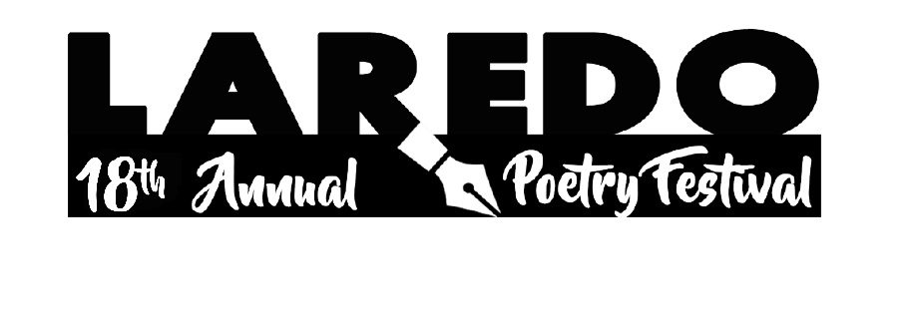
Subject:
- “This shall Pass” is the central theme for 18th Annual Poetry Festival.
- Or the theme can be any topic you may want to write about.

Rules of Participation:
- Poems must be original; plagiarized poems will be disqualified.
- Poems may be written in any format.
- Poems should be no longer than 2 pages, double-spaced.
- Submit 2 copies of your poem, 1 with no name on it.
- Only one entry per individual person will be accepted; no co-authors of a poem will be accepted.
- No poem will be accepted through fax.
- The application form needs to be filled out.
- The parents or legal guardian will fill out the Release Form for students under 18.

Language:
- English or Spanish.

Participants:
- Students from LISD, UISD, private schools, and home schooling.
- Adults 18 and over.

Method:
- Divide all contestants by age and grade level.
- The deadline for submitting poems is Tuesday, March 2, 2021, by 6:00 p.m. at the Laredo Public Library (Main Branch).
- 3-7 judges in each group will review all poems received & select the top 3 winners and 1-3 honorable mention recipients.
- The top 3 winners in each group will submit a video reading their poems by April 02, 2021, and receive prizes, a gift bag that can be pickup at Laredo Pubic Library (Main Branch)
- Honorable Mentions will receive the gift bags and can be pick-up at Laredo Public Library (Main Branch)
- All participants will receive certificates of participation.

Results:

- Publish the winners’ poems.
- Continue the Poetry Festival every year as a local educational activity.

Sponsors:
Diocese of Laredo Catholic Schools Friends of the Library Laredo College Laredo Independent School District Laredo Public Library Texas A & M International University United Independent School District Harmony Public Schools Laredo

DEADLINE FOR SUBMITTING POEMS IS TUESDAY, MARCH 2, 2021

